Report

Project overview:
Developing a web application that integrates Pixabay’s API to display and search for images and videos, and include features such as authentication, user profiles, and a favorites system. The App uses React.js for the frontend, Node.js and Express.js for the Backend, PostegresSQL for the database.

Internship summary:
As an introduction the tech lead asked me to learn Node.js and how to manage a database. Starting June 10th 2024 my first week I learned Node.js syntax and basics, but then realized that the Express.js framework is essential when using Node.js. I then spent the second week learning Express.js before jumping into mongoDB to learn database management. After 2 weeks reporting back to the tech lead he guides me to learn mySQL as it would be needed for the project. He then explains the project to me as having to do a website with a proper login system having to verify emails and jwt implementations in order to access the hompage images and videos while also being able to select favorites and having to use React.js for the frontend. Having not learned react before it seemed intimidating however the front end of the project went smoothly. While the backend was not difficult Authentication and Authorization took the most time with many issues along the way. However the project was finished in august the 10th which is when the techlead did his assessment on it.

Technologies Learned:
- React.js
  - Building components, pages, and layouts.
  - Using React Router
  - Fetching Media from the Pixabay API
- Node.js
  - routing
  - transferring data from the frontend to the back end using request response methods
- Express.js
  - Hashing passwords
  - Using JWT
  - Connecting to the database
- MongoDB
  - Creating documents and elements
  - Connecting documents with each other
- PostegreSQL
  - Creating tables
  - Altering, Updating columns and rows

Tools used for the Project:
Frontend
- React.js: For building the user interface.
- Axios: For API requests.
Backend
- Express.js: For building the RESTful API.
- JWT: For authentication and session management.
- NodeMailer: For sending verification and reset password emails.
- Mailtrap: For email testing in development.
Database
- PostgreSQL: For storing user data, favorites, etc.
Other Tools
- GitHub: For version control and collaboration.
- Docker: For having a fully setup environment

Project Structure:
The project Structure is directly split into two folders one for the frontend of the application called client and the other for the backend called server. In the client folder there is the setup files/folders for react and tailwind as well as folders I created which include components, pages, services, folders.
- Client
  - /Components
    - Navbar.jsx
The navbar was a simple react component with 3 NavLinks leading to the homepage, favorites page, and the third to logout.
    - SearchBar.jsx
The search bar component has a text input and a submit button where on change the state of the search value changes and on submit it calls a method that takes in the search value as a parameter.
    - MediaItem.jsx
This component receives a as a prop a Json object called item and a Boolean value called like. Depending on the values inside the Json object the media item is either a still image or a thumbnail with a play icon above it and once clicked the video in relation to the media item is displayed. The media item also has a heart icon on it top right where once clicked sends a post request to the backend to set this item as favorite for the current user and the icon changes.
    - ProtectedRoute.jsx
This component only checks if there is a token in the local storage and returns either the intended route or if the token is not found it navigates the user back to the login
  - /Pages
    - Homepage.jsx (placed as protectedRoute)
The homepage calls the fetchMedia fuction from the /Services/PixabayService.js and displays all the media returned in a grid pattern through the mediaItem component where each one takes an item from the data returned as a prop and displays it. In addition the hompage uses the Navbar and the searchbar components where once the search is submitted the query is sent into the fetch media where the function is called again and now the displayed media is based on the searched query. Moreover, each item is goes through the favorited media items which are brought from the database using a post request to check if the items should be set as like or not like once displayed in the homepage
    - FavoritesPage.jsx (placed as protectedRoute)
This page sends a post request to the backend that returns all the favorited media items then loops over them to display them in the media items component using a grid system
    - LoginPage.jsx
This page has a form that takes in an email and a password which are sent to the backend through a post request and then verified. Based on the backend response this page either allows or rejects entry to the homepage.
    - SignupPage.jsx
This page has a form that takes in an email, password and confirm password which are sent to the backend through a post request. Then a user is created, and a verification email is sent to them.
    - VerifyEmail.jsx
A get request is sent to the backend to verify the user who has entered
  - /Services
    - PixabayService.js
This file has a main function called ‘fetchMedia’ which sends 2 get requests to the pixabay API, one for the images and one for the photos. Then the returned data is joined together in a list and in order to randomize the order of the data the fisherYatesShuffle is performed on the list 5 times and then a list of json objects containing the data is returned.
  - App.js
This has a the react router setup with the following routes setup
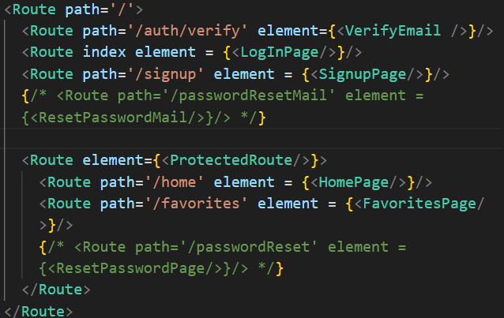
- server

